TITLE GOES HERE
Author A. One^{*1,2}, Presenting Author ^{†1}, Author C. Three^{‡2}, and Author D. Four³ 1Affiliation 1, Country1
2Affiliation 2, Country2
3Affiliation 3, Country3

Keywords: x-ray tomography, in-situ, tensile testing, digital volume correlation

Summary: Short summary of maximum 4 lines

INTRODUCTION

In recent years, significant progress has been made in exploring wonderful things in three dimensions [2]. In the following, a new process by which this procedure can be enhanced is described...

  - Please follow the format of the section headings and the general structure of the template
  - The abstract should be maximum 2 pages long and submitted as pdf
  - Include e-mail address for at least the presenting author
  - Provide 4 keywords of your choice, but using some of the topics of the conference would help fitting your paper in to the most appropriate session
  - Actual section titles can be changed as appropriate
  - Please include ONE figure on the second page

EXPERIMENTAL METHOD

The experiments were performed at the X25 beamline of the Wonderful Synchrotron Facility (WSF), in Bahamas...

  - Describe the main details of the experimental set-up and or analysis method

*e-mail: author.one@university.edu
†e-mail: author.two@university.edu
‡e-mail: author.three@university.edu

RESULTS

The results show the first 3D image of an alien species from planet Kryptonite (Fig. 1(a)) disguise as the Great Barrier Reef (see Fig. 1(b)).

  - Outline the main results/findings from the work

References

- A.B. Author & B.C. Worker. Why superman has x-ray vision, Nature, 100, 1079–1082, 2017.
- A.N. Other, Y.E.T Another & M.E. Too. Three-dimensional imaging for material science, Imaging Letters, 5, 236–242, 2015.

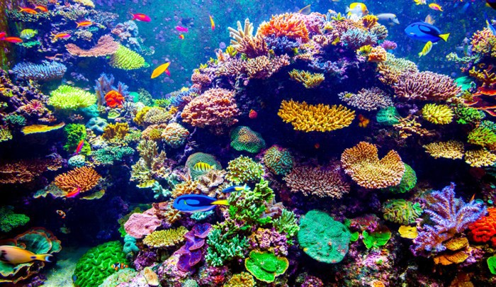
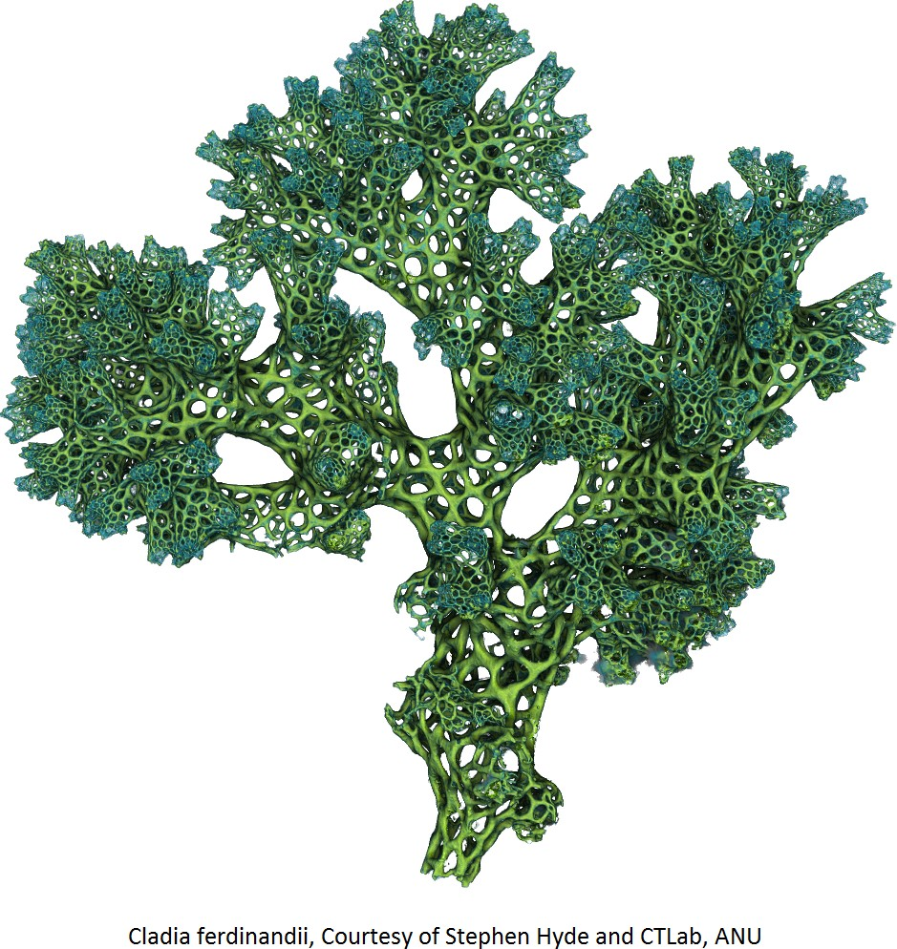
  - (b)

Figure 1: (a) Cladia ferdinandii - courtesy of Stephen Hyde (CTLab, ANU). (b) Reef life (courtesy of: https://tropicdays.com.au/great-barrier-reef-trip-coral-types/)

